# Test 1

* The google solar api did not pickup the main house(green highlighter) only the secondary garage
* The main house was built in 2019 and the secondary garage sometime in the 80’s, this could be indicative of inherent problems with using Google Solar API
* The solar model was from 2016 so almost 10 years old

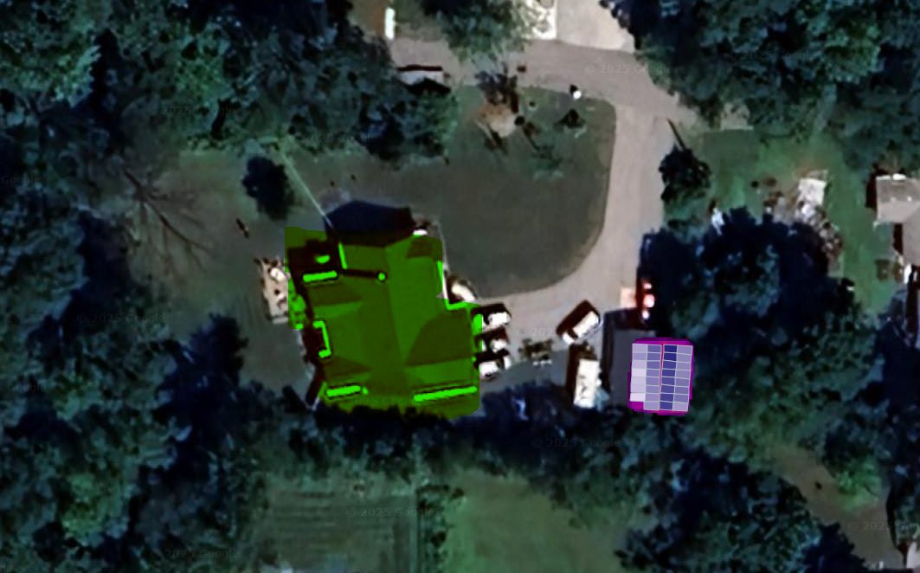

# Test 2

* The google solar api did not pickup the roof correctly added the neighbors sheds as part of the property when they are not
* These buildings were built back in the 60’s

